BAM DONKEY WELFARE TRAINING IN KWEEN DISTRICT 25TH TO 27THAUGUST 2022.
Background:
Training donkey owners on how to make sisal sack saddles for donkeys to protect them from ill health due to wounds caused by poor/no harnessing in the Eastern region of Uganda covering the Districts of Kween , Bukwo and Kapchorwa .
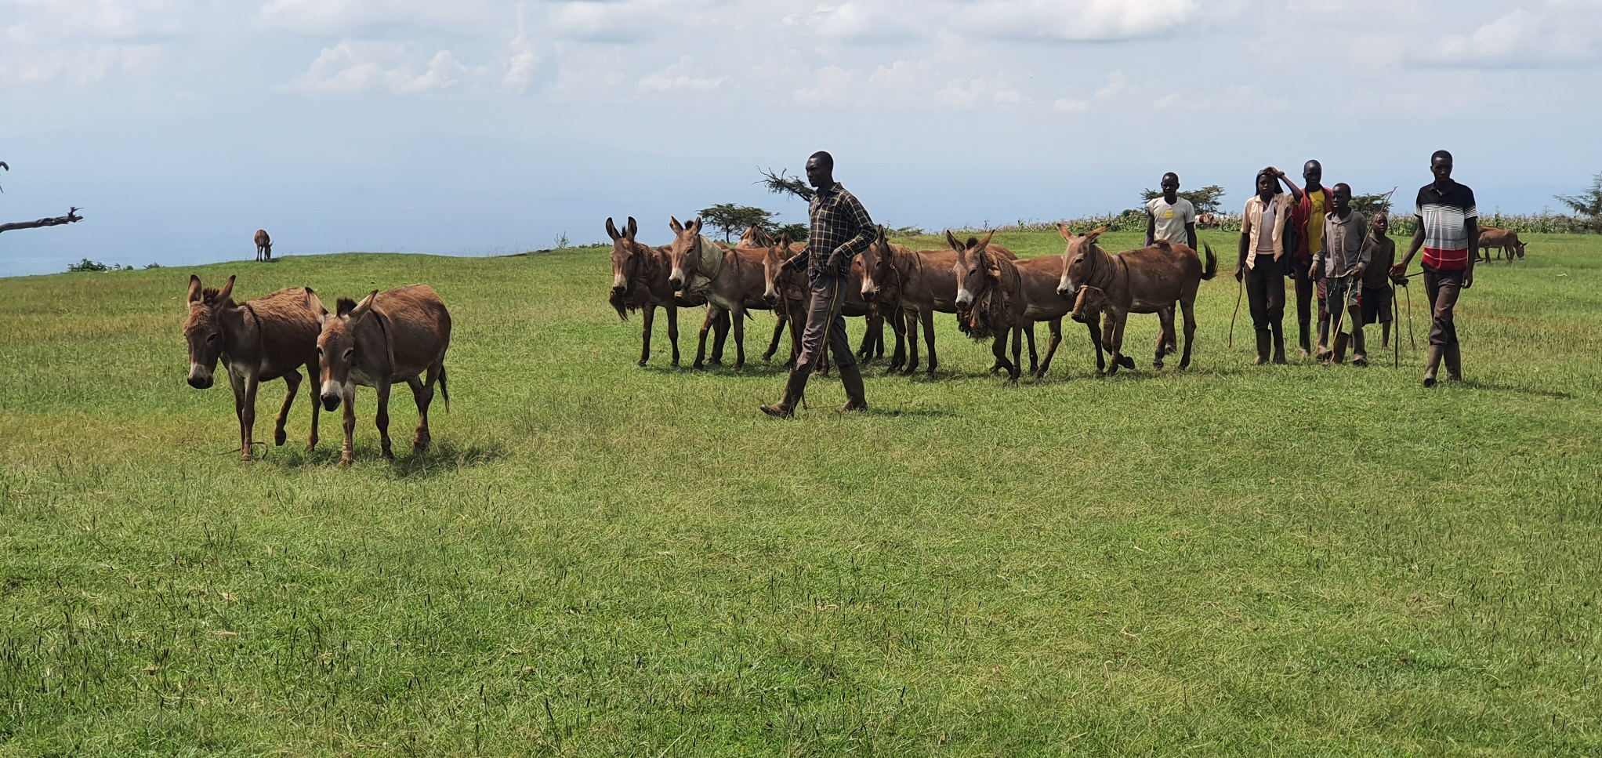
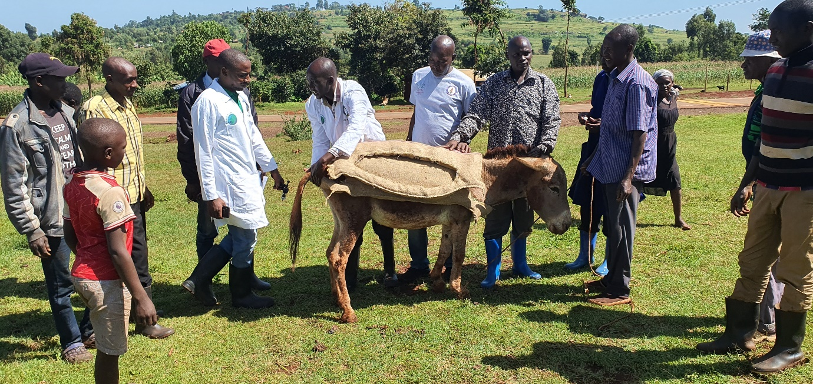The donkey is a solipede of the family equidae, species Equus asinus. It is an important draft animal in many parts of the world. Donkeys play an essential role in the agricultural economies of underdeveloped countries. However, these animals have not yet been given sufficient care, although they are subjected to many diseases and generally poor welfare which affect their viability and lower their ability to work. Despite the increasing importance of donkeys in Uganda, there exists no formal training relating to donkeys’ welfare. Donkey power is an environmentally friendly means of transport, indispensable in areas of poor roads and bad terrains. Donkeys appear resistant to many diseases. Donkey can comfortably pull more weight than it can carry, provided the harness is suitable.
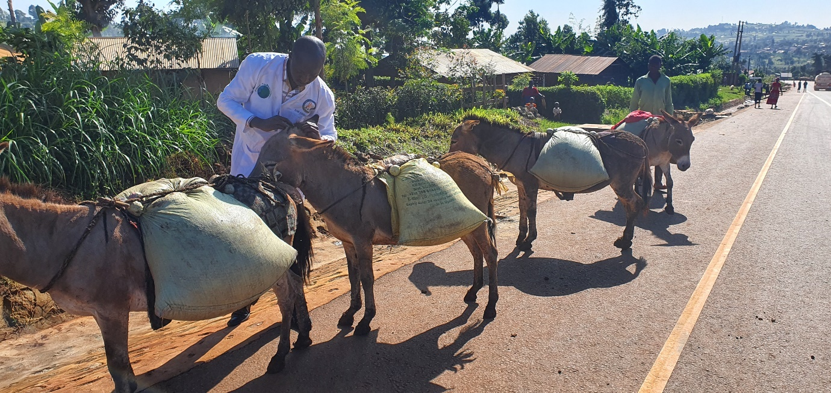
From 24th August to 27th 2022, Bam animal clinics team held several Donkey welfare trainings activities in clusters organized by our contact staff in Kween District Kaproron Subcounty.
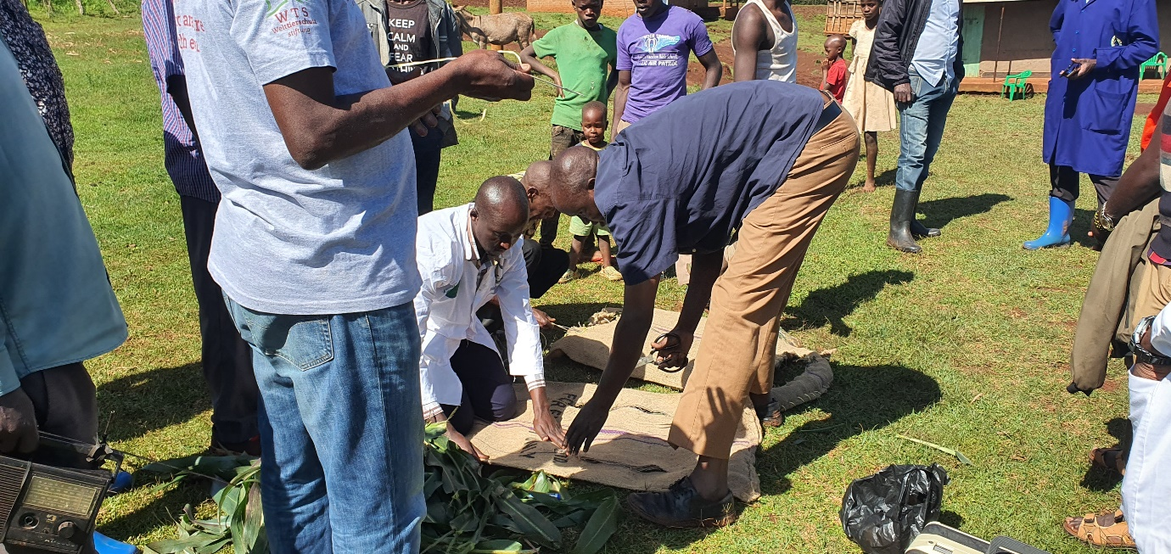
The team left very early morning to start tracking down on especially donkeys that transport produce to market places because most welfare issues are observed in transportation. As soon as we started our journey, we encountered a donkey owner who had his donkeys ferrying firewood to Kapchorwa town. The donkeys were heavily loaded and without proper saddles. The team stopped him and engaged him to ensure he knew the basic welfare requirements of his transport animals.
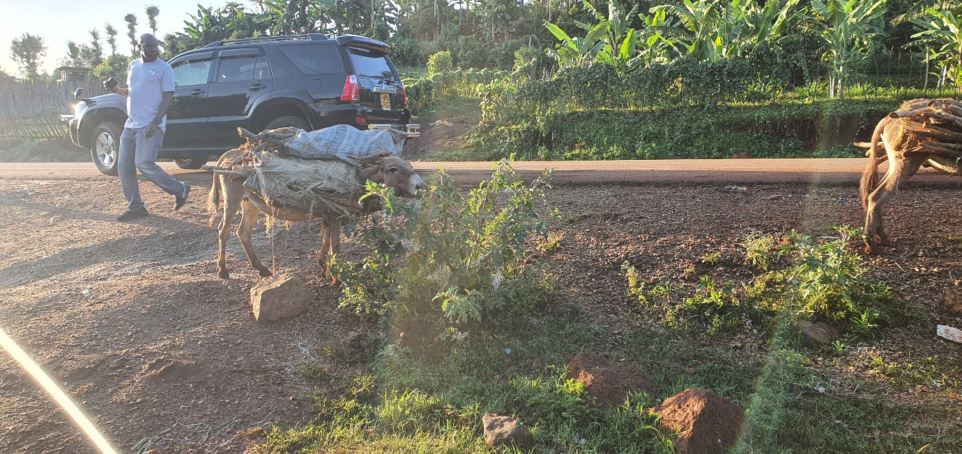
Soon after, a lady also on the other side had her donkeys badly loaded with food to market she refused to stop in fear.
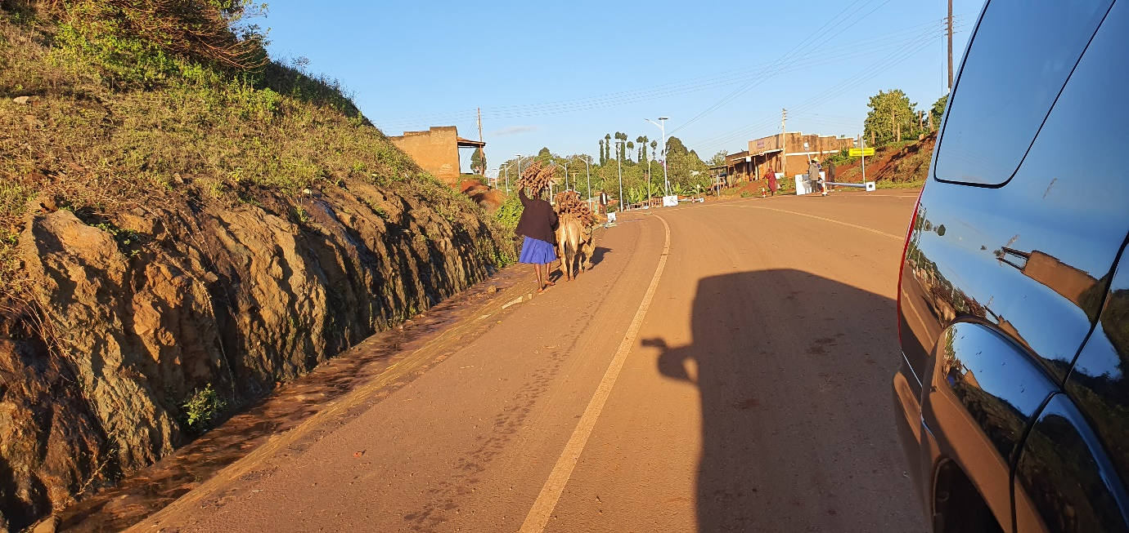
The region is a resident for so many world athletics stars and a very morning, hundreds of them storm the highways to train.
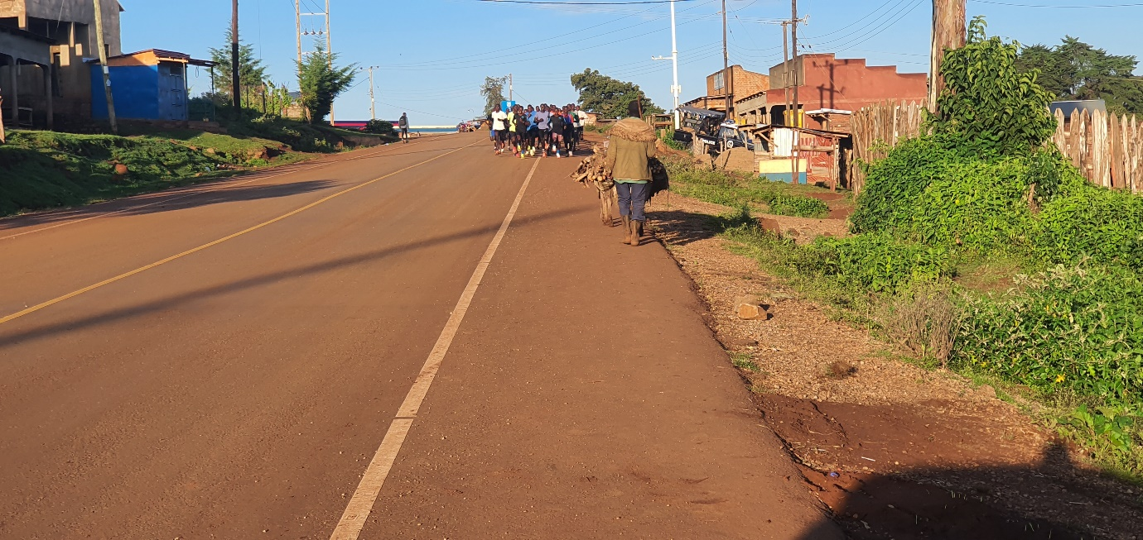

On a muddy morning, our car sometimes is unable to continue and we have to walk to reach more distant places to meet the donkey owners to talk to them.
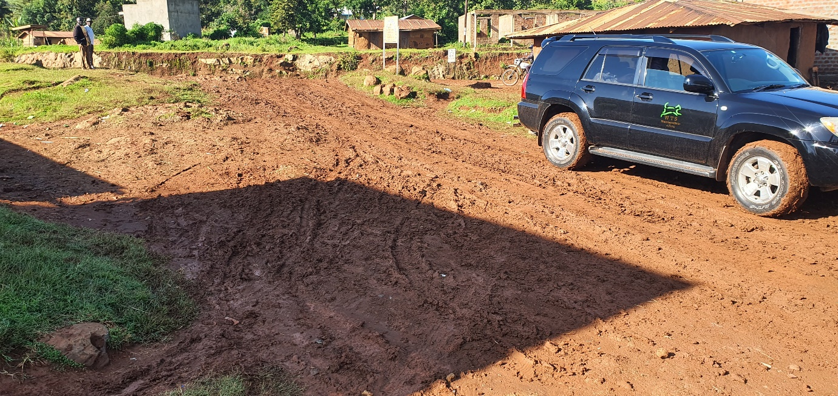
Sometimes it’s hard to have all the donkey owners to come and attend our humane handling training programs, this is partly because of the terrains that separate places very sharply or people on unknown reasons. Tracking them while they move to markets and sometimes from the gardens to homes has been of much help because, meeting these animals in the usual working conditions gives the right understanding of how much the pain they go through to be able to support in accordance.
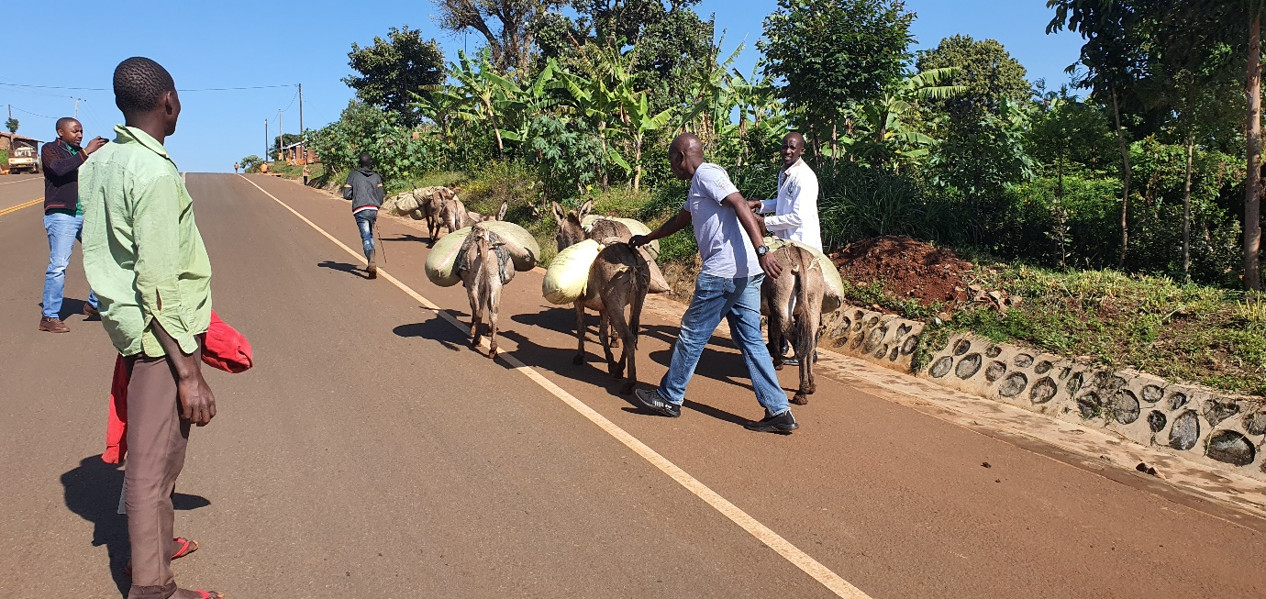

Our team in Kaproron Kween observed a lot of welfare issues with these donkeys including over loading, the use of inappropriate saddles evidenced by the damages on the back of the donkeys and wounds behind their tails.
Majority of Donkey owners care less about the types of Saddles they use on their working donkeys.
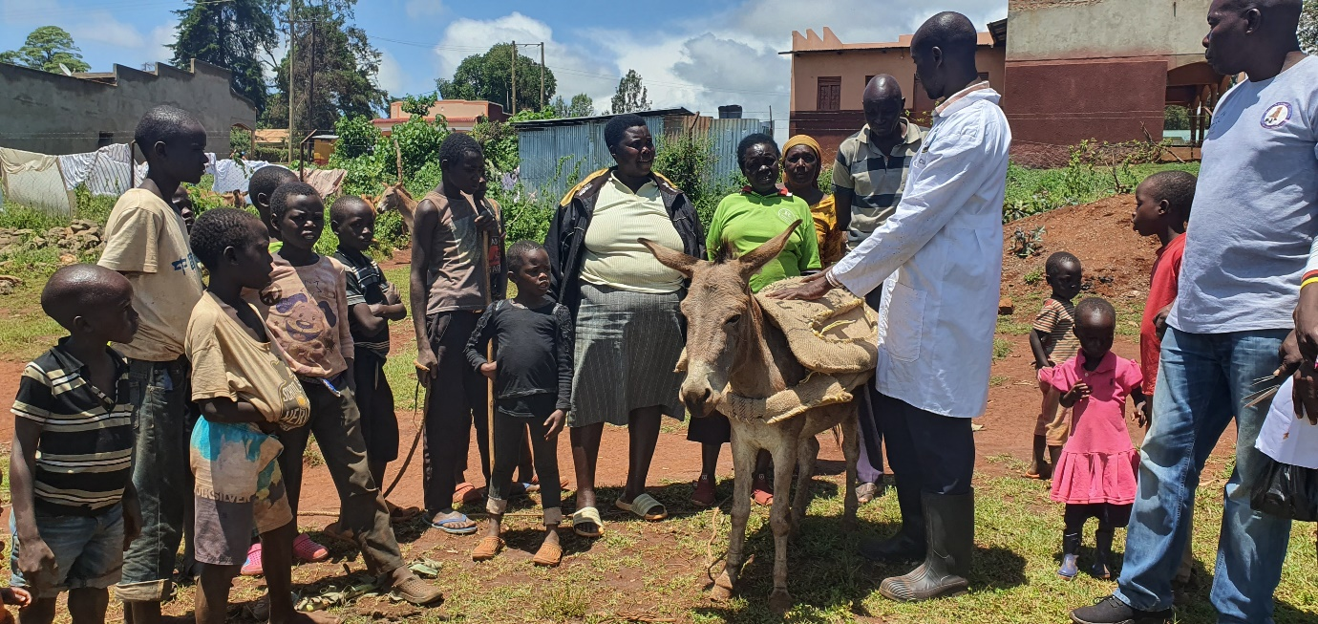
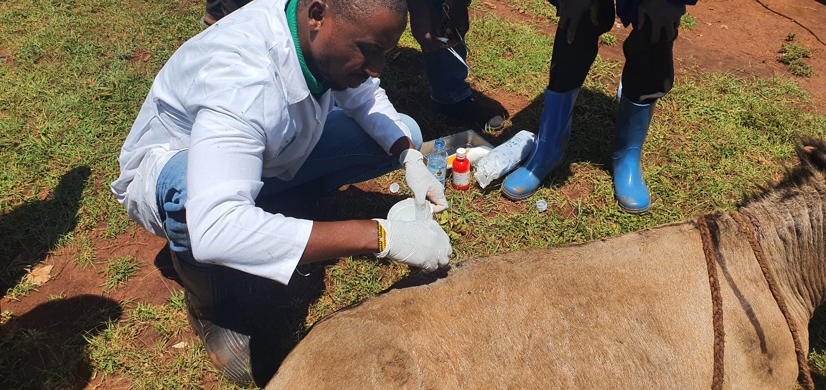
Inappropriate use of Saddles will lead to lots of wounds and sores on working donkeys. Bam together with Animal-Kind International we have developed a new type of Saddle made out of sisal sacks. It's easy to make and use saddle that will help to minimize injuries as a result of using the older type of saddles

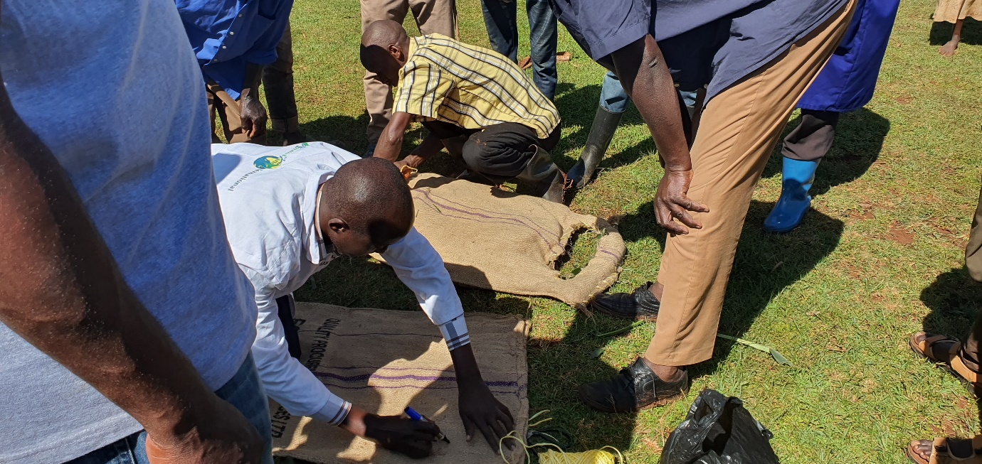

The owner of this donkey told us her donkey was multipurpose and that she could use her for ploughing, transport of all sorts of goods. When we examined the donkey critically, she had lots of wounds around and needed urgent help. We immediately managed the wounds and would follow up to ensure the donkey was in good shape. The owner was advised to rest the donkey till the wounds were healed and she was trained how to make humane saddles to mitigate on injuries as was the case before.
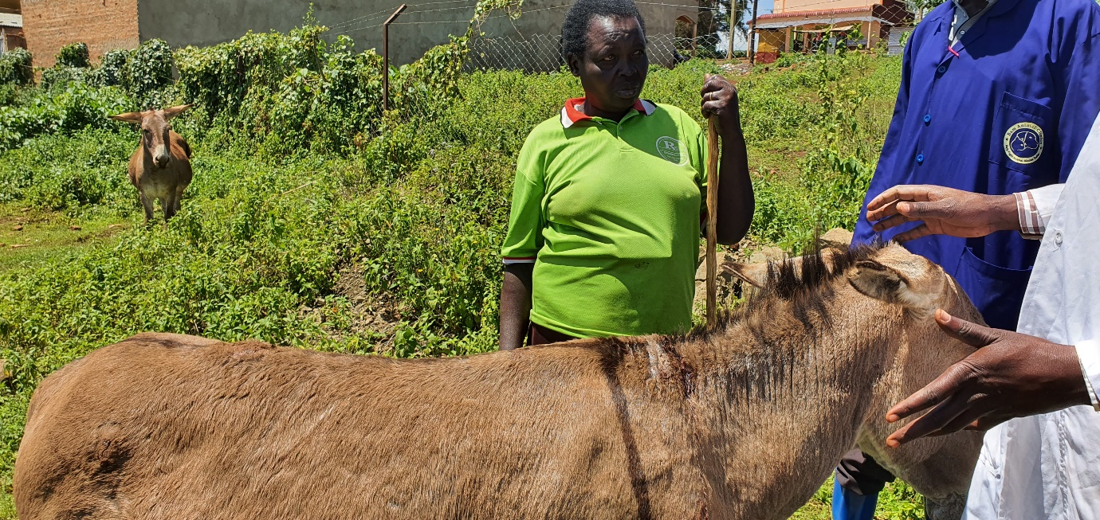

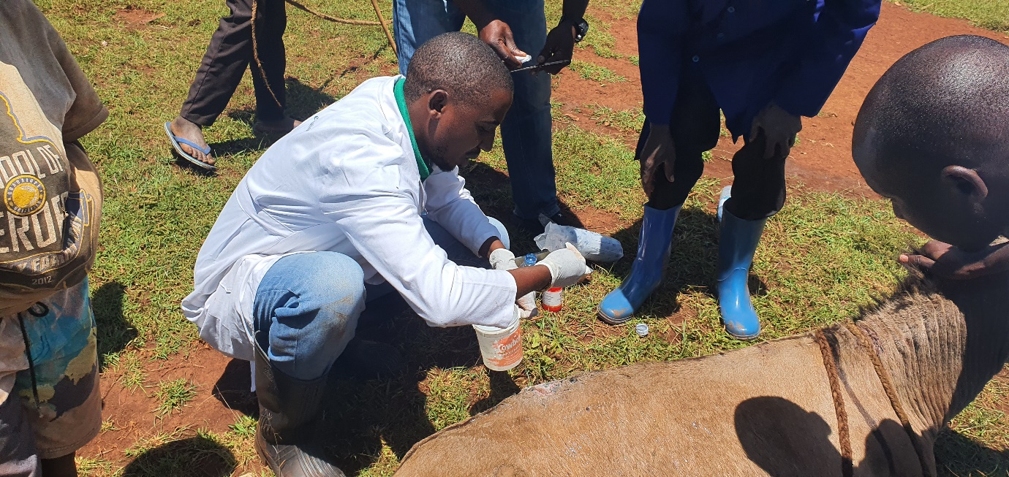
Home to home visits amongst the donkey keeper communities in Kween District. The aim is to keep identifying challenges and progresses made by Bam animal clinics over the past years of training of these communities in animal welfare. We observed a bit of attitude changes registered by show of care as opposed to the hustling there used to be.
